Demonstrate implementation of Query Methods feature of Spring Data JPA

Query Methods - Search by containing text, sorting, filter with starting text, fetch between dates, greater than or lesser than, top

Query methods - https://docs.spring.io/spring-data/jpa/docs/2.2.0.RELEASE/reference/html/#jpa.query-methods.query-creation

| **Description** | **URL** |
| --- | --- |
| Search by name | <http://localhost:8080/employees/search?keyword=Ali> |

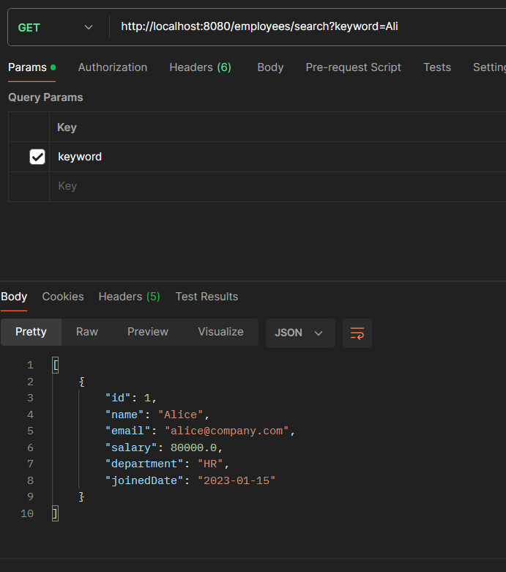

Department Starts With <http://localhost:8080/employees/department?prefix=H>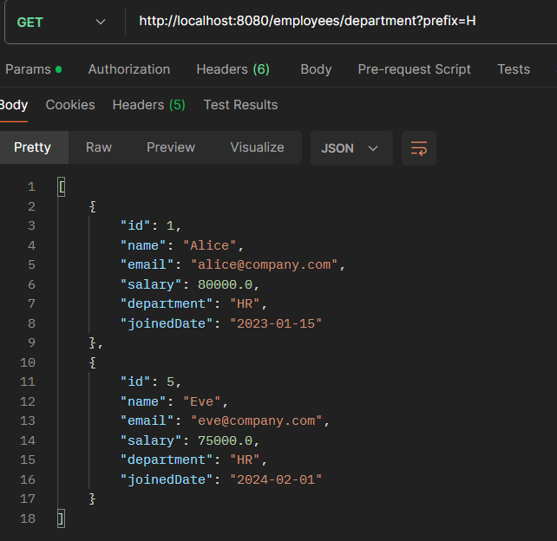

|  |  |
| --- | --- |
| Sort by salary descending | <http://localhost:8080/employees/sorted> |
|  |  |

Joined b/w dates <http://localhost:8080/employees/joined?from=2022-01-01&to=2024-12-31>

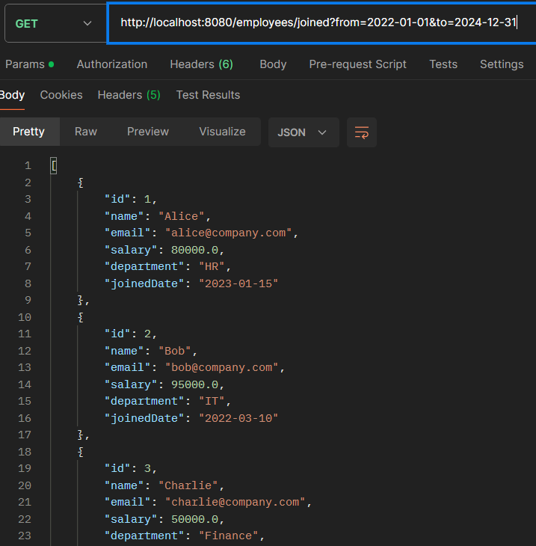

Salary Greater Than <http://localhost:8080/employees/high-salary?salary=80000>

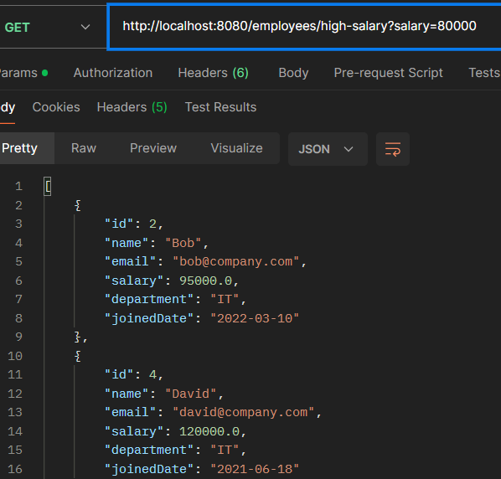

Salary less than <http://localhost:8080/employees/low-salary?salary=60000>

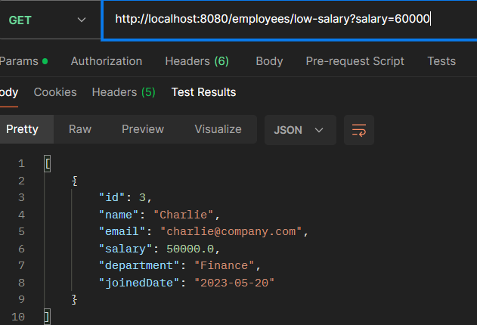

Top 3 highest paid <http://localhost:8080/employees/top3>

